Irregular Triangular Pyramid
# Source: AI Source: Provided by: [Data Path: Persons Table -> ID Column: 1, Name_En Column: Motasem Essam] -> From: [ChatGPT] on [7/25/2026]
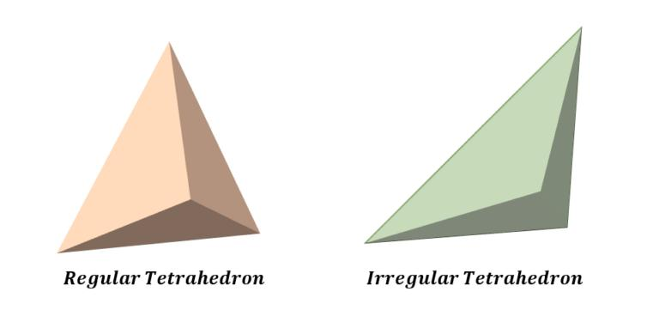

Definition
# Source: AI Source: Provided by: [Data Path: Persons Table -> ID Column: 1, Name_En Column: Motasem Essam] -> From: [ChatGPT] on [7/25/2026]
An irregular triangular pyramid is a three-dimensional solid with a triangular base and three triangular lateral faces, where the triangles or the overall arrangement do not satisfy the conditions required for a regular tetrahedron.
It is also called an irregular tetrahedron when referring to the general tetrahedral solid that is not regular.
The base may be scalene or isosceles, and the lateral faces may have different side lengths and angles. The apex does not have to lie directly above the center of the base.
Important: An irregular triangular pyramid does not necessarily have all unequal edges. It may have some equal edges or congruent faces while still not being a regular tetrahedron.

Simple Definition
# Source: AI Source: Provided by: [Data Path: Persons Table -> ID Column: 1, Name_En Column: Motasem Essam] -> From: [ChatGPT] on [7/25/2026]
An irregular triangular pyramid is a pyramid with four triangular faces that does not have all the properties of a regular tetrahedron.

Key Characteristics
# Source: AI Source: Provided by: [Data Path: Persons Table -> ID Column: 1, Name_En Column: Motasem Essam] -> From: [ChatGPT] on [7/25/2026]
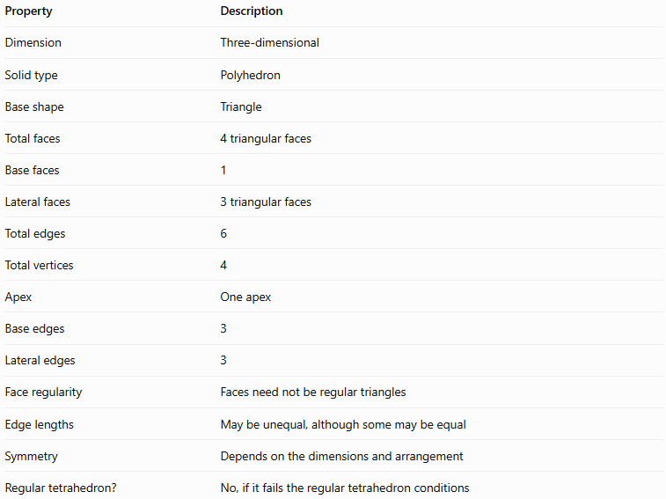
Property | Description
Dimension | Three-dimensional
Solid type | Polyhedron
Base shape | Triangle
Total faces | 4 triangular faces
Base faces | 1
Lateral faces | 3 triangular faces
Total edges | 6
Total vertices | 4
Apex | One apex
Base edges | 3
Lateral edges | 3
Face regularity | Faces need not be regular triangles
Edge lengths | May be unequal, although some may be equal
Symmetry | Depends on the dimensions and arrangement
Regular tetrahedron? | No, if it fails the regular tetrahedron conditions

Geometric Representation
# Source: AI Source: Provided by: [Data Path: Persons Table -> ID Column: 1, Name_En Column: Motasem Essam] -> From: [ChatGPT] on [7/25/2026]
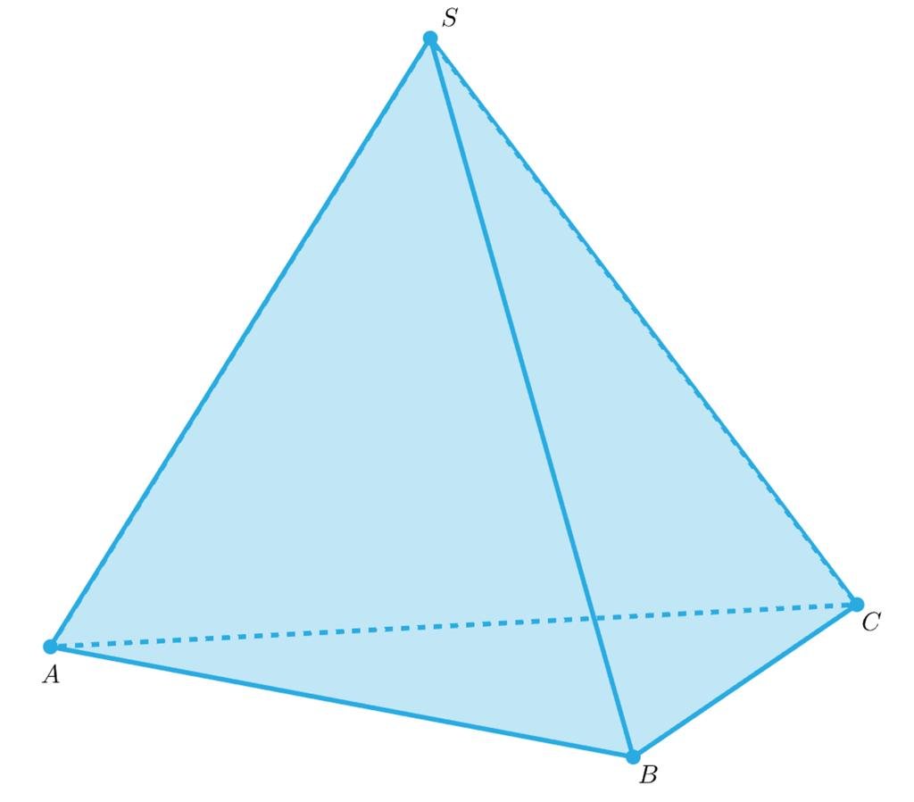
An irregular triangular pyramid consists of the following components:
- Triangular base $ABC$: The triangle forming the bottom or designated base of the pyramid.
- Apex $S$: The vertex that is not part of the base.
- Lateral faces $SAB$, $SBC$, and $SCA$: Three triangles connecting the apex to the base edges.
- Base edges $AB$, $BC$, and $CA$: The three edges around the base.
- Lateral edges $SA$, $SB$, and $SC$: The three edges connecting the apex to the base vertices.
- Perpendicular height $h$: The shortest perpendicular distance from the apex to the plane containing the base. Its foot may lie inside or outside the base triangle.

Mathematical Representations and Formulas
# Source: AI Source: Provided by: [Data Path: Persons Table -> ID Column: 1, Name_En Column: Motasem Essam] -> From: [ChatGPT] on [7/25/2026]
Let:
- $B$ = area of the triangular base.
- $h$ = perpendicular height of the pyramid.
- $A_{T}$ = total surface area.
- $A_{L}$ = lateral surface area.
- $P_{b}$ = perimeter of the base.

Number of faces, edges, and vertices
# Source: AI Source: Provided by: [Data Path: Persons Table -> ID Column: 1, Name_En Column: Motasem Essam] -> From: [ChatGPT] on [7/25/2026]
For a triangular pyramid, $n=3$.
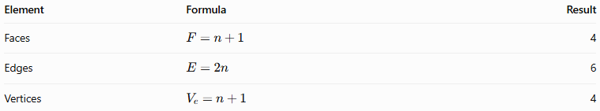
Element | Formula | Result
Faces | $$F=n+1$$ | 4
Edges | $$E=2n$$ | 6
Vertices | $$V_{e}=n+1$$ | 4
Euler’s formula for convex polyhedra is:
$$V_{e}-E+F=2$$
Substituting the values:
$$4-6+4=2$$
Therefore, the triangular pyramid satisfies Euler’s formula.

6.2 Volume
# Source: AI Source: Provided by: [Data Path: Persons Table -> ID Column: 1, Name_En Column: Motasem Essam] -> From: [ChatGPT] on [7/25/2026]
The volume of any triangular pyramid is:
$$\boxed{V=\frac{1}{3}Bh}$$
If the base triangle has base length $b$ and perpendicular triangle height $h_{b}$, then:
$$B=\frac{1}{2}bh_{b}$$
Therefore:
$$\boxed{V=\frac{1}{6}bh_{b}h}$$
Here, $h_{b}$ is the height of the base triangle, while $h$ is the perpendicular height of the entire pyramid.

6.3 Surface area
# Source: AI Source: Provided by: [Data Path: Persons Table -> ID Column: 1, Name_En Column: Motasem Essam] -> From: [ChatGPT] on [7/25/2026]
The total surface area is the sum of the areas of all four triangular faces:
$$\boxed{A_{T}=B+A_{1}+A_{2}+A_{3}}$$
where $A_{1}$, $A_{2}$, and $A_{3}$ are the areas of the three lateral faces.
The lateral surface area is:
$$\boxed{A_{L}=A_{1}+A_{2}+A_{3}}$$
For an irregular triangular pyramid, the lateral faces may have different dimensions, so their areas should generally be calculated separately.
For any triangular face with side lengths $a,b,c$, Heron's formula can be used:
$$s=\frac{a+b+c}{2}$$
$$A=\sqrt{s\left(s-a\right)\left(s-b\right)\left(s-c\right)}$$
where $s$ is the semiperimeter of that face.

6.4 Slant heights
# Source: AI Source: Provided by: [Data Path: Persons Table -> ID Column: 1, Name_En Column: Motasem Essam] -> From: [ChatGPT] on [7/25/2026]
Unlike a regular tetrahedron, an irregular triangular pyramid generally does not have one common slant height for all three lateral faces.
Each triangular face may have its own altitude, depending on the face's dimensions. Therefore, calculate each lateral face's area separately unless the geometry provides a valid shared-height relationship.

Worked Examples
# Source: AI Source: Provided by: [Data Path: Persons Table -> ID Column: 1, Name_En Column: Motasem Essam] -> From: [ChatGPT] on [7/25/2026]
Example 1: Calculating the number of elements
An irregular triangular pyramid has a triangular base. Determine its number of faces, edges, and vertices.
Solution:
- Faces: $3+1=4$
- Edges: $2\left(3\right)=6$
- Vertices: $3+1=4$
Answer: 4 faces, 6 edges, and 4 vertices.
Example 2: Calculating volume
Suppose the base triangle has an area of $12{\text{ cm}}^{2}$, and the perpendicular height of the pyramid is $9\text{ cm}$.
Using:
$$V=\frac{1}{3}Bh$$
Substitute the values:
$$V=\frac{1}{3}\left(12\right)\left(9\right)$$
$$V=36{\text{ cm}}^{3}$$
Answer: The volume is $36{\text{ cm}}^{3}$.
Example 3: Calculating total surface area
Suppose the base area is $10{\text{ cm}}^{2}$, and the lateral face areas are $8{\text{ cm}}^{2}$, $11{\text{ cm}}^{2}$, and $13{\text{ cm}}^{2}$.
$$A_{T}=10+8+11+13$$
$$\boxed{A_{T}=42{\text{ cm}}^{2}}$$
Answer: The total surface area is $42{\text{ cm}}^{2}$.

Comparison with Related Concepts
# Source: AI Source: Provided by: [Data Path: Persons Table -> ID Column: 1, Name_En Column: Motasem Essam] -> From: [ChatGPT] on [7/25/2026]
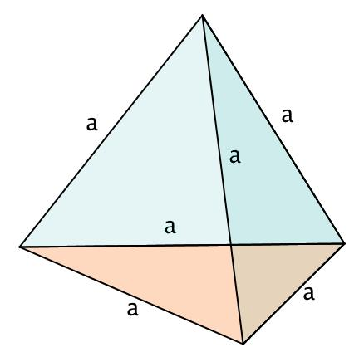
Regular Tetrahedron
A special triangular pyramid with four congruent equilateral triangular faces and six equal edges. It is highly symmetrical.
Irregular Triangular Pyramid
Has four triangular faces but does not meet the regular tetrahedron conditions. Its edges, faces, and symmetry may differ.
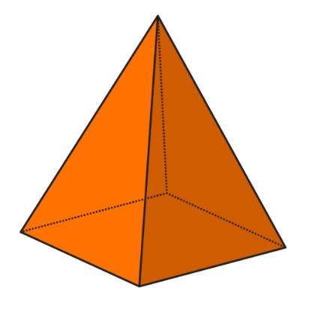
Quadrilateral Pyramid
Has a four-sided base and four lateral triangular faces, giving five faces in total. An irregular triangular pyramid has only a triangular base.
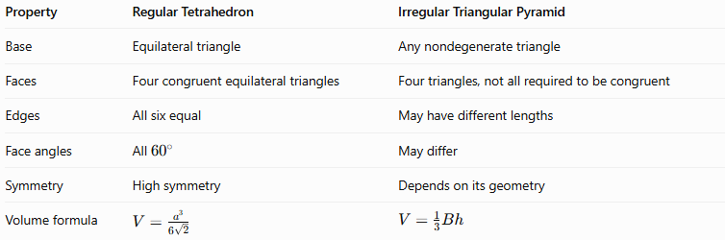
Property | Regular Tetrahedron | Irregular Triangular Pyramid
Base | Equilateral triangle | Any nondegenerate triangle
Faces | Four congruent equilateral triangles | Four triangles, not all required to be congruent
Edges | All six equal | May have different lengths
Face angles | All ${60}^{∘}$ | May differ
Symmetry | High symmetry | Depends on its geometry
Volume formula | $$V=\frac{a^{3}}{6\sqrt{2}}$$ | $$V=\frac{1}{3}Bh$$
The regular tetrahedron formula uses $a$, the common edge length. For an irregular triangular pyramid, the general formula $\frac{1}{3}Bh$ is the appropriate choice.

Applications
# Source: AI Source: Provided by: [Data Path: Persons Table -> ID Column: 1, Name_En Column: Motasem Essam] -> From: [ChatGPT] on [7/25/2026]
Irregular triangular pyramids can be used to represent or approximate:
- Architecture: Triangular roof supports and nonuniform pyramid-shaped structures.
- Engineering: Tetrahedral structural elements with different dimensions.
- Computer graphics: Tetrahedral mesh elements used in three-dimensional modeling and numerical simulations.
- Finite element analysis: Three-dimensional tetrahedral elements that divide complex objects into smaller regions for calculations.
- Geometry education: Exploring how volume, surface area, edge lengths, and symmetry change when a regular tetrahedron is distorted.

Key Points
# Source: AI Source: Provided by: [Data Path: Persons Table -> ID Column: 1, Name_En Column: Motasem Essam] -> From: [ChatGPT] on [7/25/2026]
- An irregular triangular pyramid is a polyhedron with four triangular faces.
- It has 6 edges, 4 vertices, and 1 triangular base.
- It is a type of tetrahedron, but it is not a regular tetrahedron.
- Its edges and faces may have different dimensions.
- Its volume is $\frac{1}{3}Bh$.
- Its total surface area is the sum of the areas of its four triangular faces.
- Euler’s formula gives $4-6+4=2$.
- It does not necessarily have a common slant height or a high degree of symmetry.

Conclusion
# Source: AI Source: Provided by: [Data Path: Persons Table -> ID Column: 1, Name_En Column: Motasem Essam] -> From: [ChatGPT] on [7/25/2026]
An irregular triangular pyramid is a tetrahedral solid whose geometry does not satisfy all the conditions of a regular tetrahedron. Although it always has four triangular faces, six edges, and four vertices, the dimensions of its faces and edges can vary. Its volume is calculated using one-third of the base area multiplied by the perpendicular height, while its surface area is found by adding the areas of all four triangular faces.
Understanding irregular triangular pyramids helps distinguish general tetrahedra from regular tetrahedra and provides a foundation for studying more complex polyhedra.

